Friday Outing – Panhandle Adventure Tour
11:00am – 5:00pm
Transportation provided to tour 3 venues located in the Palo Duro Canyon area. This fee includes transportation, lunch and beverages at Creek House Honey Farm, Palo Duro Canyon tour, and Bar Z Winery. Cost for the entire excursion is $90.00 per person and needs to be paid to DPI at the time of registration. Space is limited to 50 passengers so reservations will be on a first come first serve basis.

RETURN THIS FORM WITH YOUR REGISTRATION IF YOU WOULD LIKE TO PARTICIPATE

Name:
Name:
Name:
Name:

Pay by Credit Card - call Dawn or Kris or enter CVV code here for card on file:

1st Stop Creek House Honey Farm, Canyon, TX
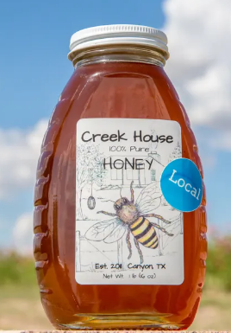

2nd Stop Palo Duro Canyon
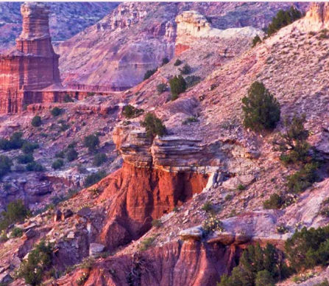

3rd Stop Bar Z Winery, Canyon, TX

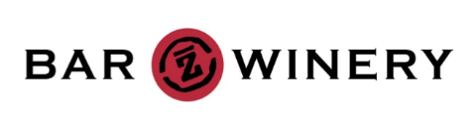

Return back to the Embassy Suites at approximately 5:00pm.

